Project Plan
Szymon Gancarz

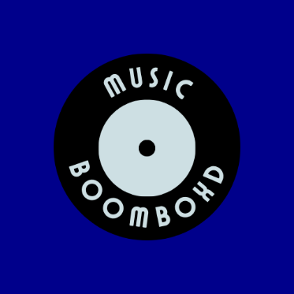

Music BoomBoxd

Date : 05/03/2024
Version : 2.1
State : Finished
Author : Szymon Gancarz

Version history

Version | Date | Author(s) | Changes | State
0.1 | 05/03/2024 | Szymon Gancarz | Made a beginning on the project plan. | Finished
1.0 | 07/03/2024 | Szymon Gancarz | First version completed | Finished
2.0 | 08/03/2024 | Szymon Gancarz | The second version completed | Finished
2.1 | 20/03/2024 | Szymon Gancarz | Improved the project plan after discussing it with one of the teachers | Finished

Glossary

ICT | Information Communication Technology
ISSD | ICT Student Service Desk
URS | User Requirements Specification Document
OS | Computer Operating System
CRUD | Create, Read, Update, and Delete
UI | User Interface

Contents
1. Project assignment 4
1.1 Context 4
1.2 Goal of the project 4
1.3 Constrains 5
1.4 Scope and preconditions 5
1.5 Strategy 6
1.6 Research questions 6
1.7 End products 7
2. Project Organisation 8
2.1 Stakeholders and team members 8
2.2 Communication 8
3. Activities and time plan 9
3.1 Phases of the project 9
3.2 Time plan and milestones 9
4. Testing strategy and configuration management 10
4.1 Testing strategy 10
4.2 Configuration management 10
5. Finances and Risk 11
5.1 Risk and mitigation 11

Project assignment

Context

This application will help you find more new music and friends who like the same genres by reviewing and commenting on different artist and music. They will be able to select their 5 favorite albums and 5 favorite songs to display them in their user profile. The application will also allow users to fill out a form on the website where they will be able to recommend songs, albums, and artists that they would like to be added to the website. The form would later be analyzed by me, and I will decide if I should add the songs, albums, or artists they have requested. The app will show you the most recent and upcoming albums. You will be able to set a notification for when a new album or song comes out. There will also be a section for the most popular albums and artists that will be selected by the number of comments and likes under an album or artist.

Goal of the project

The why, what is the reason for doing this project ?

The reason for doing this project is to create a social platform dedicated to music enthusiasts by providing space where users can discover new music, connect with like-minded people, and engage in meaningful discussions about albums, songs, artists. With this project I aim to enhance the music exploration experience and create a better sense of community among users with shared interests.

What would the new preferred situation look like?
In the new preferred situation, the Music BoomBoxd will become a community where users can discover and discuss music and artists. The application will enable users to share recommendations, engage in discussions, and customize their profiles to showcase their favourite albums, songs, and artists. They will be able to organize their pages by genres which will create spaces for users to connect with like-minded people.

What are the advantages of this project?

Some of the advantages of this project are:
- Users will be able to easily discover new music through recommendations, reviews, and discussions with other members of the community.
- Users will be able to find new friends and connect with people with similar interests in music. This will create a more engaging and enjoyable music exploration experience.
- The ability for users to write reviews, rate music and recommend songs will foster a dynamic and user-driven content ecosystem.
- By introducing different user categories will add a layer of credibility to the content which will allow users to indicate the relevance of comments and reviews on the user’s expertise

How does this project add value to the company/context?

- Thanks to the applications interactive features like comments, likes and recommendations will contribute to higher user engagement making the platform more appealing and increasing user engagement.
- The application’s structure will allow for the collection of valuable data on user preferences, popular music and emerging trends which will provide insights that can be leveraged for future improvements.
- Music BoomBoxd is different from other traditional music streaming platforms by combining social interactions with music discovery which will attract users who are looking for a more community-oriented experience.

Which possibilities are offered by the ICT product that the project will realize?

- The project utilizes ICT to allow users to customize their profiles and showcase their favourite music.
- ICT enables efficient categorization of music by year, genre, and popularity, enhancing the search the discovery capabilities for users.
- ICT will enhance the overall music exploration experience and add significant value to the company or context.

Constraints

C.1 A Windows Forms App
I must use C# and .NET Framework. The Program has to run on a Windows OS

C.2 A Web App
I must use C# and Razor Pages ASP.Core Framework. Minimal JavaScript (I will not be learning any)

C.3 Time (& Budget)
I only have 6 weeks to finish this project. Budgetary constraints and resource availability may impact the scope and timeline of the project implementation (e.g. deliverables), and therefore the quality of the product.
C.4 Expertise of Users
Users will be regular people, so my software needs to be simple and intuitive. All administration and CRUD tasks should be done from a friendly UI.

Scope and preconditions

Inside scope: | Outside scope:
- Review system for songs, albums, and artists | - Genre-specific chat feature
- Like, comment and report feature for reviews | - Relevance-based comment display, giving them more visibility
- Display most recent and upcoming albums | - Verification of user accounts and the criteria for deciding if a user’s recommendations should be added to the website and grant them access to add songs by themselves.
- Set a reminder for most recent and upcoming albums
- User profile creation and customization
- Displaying user’s 5 favorite albums and songs on their profile
- Form to add song, album, and artist
- Section for popular albums and artists based on comments and likes
- Categorization for users into professionals, artists and amateurs
- Search for songs, albums, and artists
- Searchable by year, genre, and popularity

The project will have a user authentication system and a review system for songs, albums, and artists. The functionality needs to be robust, secure, and user-friendly. It is very important to review the sufficiency of the system in promoting user engagement and content quality.
This application aims to become a community-driven platform, so scalability is an essential factor here. The technology choices made should be capable of handling potential growth in user numbers, data volume, and feature expansion.
There may be constraints related to the project budget and timeline, which could impact the scope of the project and the level of detail in the deliverables. It's essential to consider these preconditions when planning the project to ensure realistic expectations and effective resource allocation.
The project will need user testing and feedback loops to refine and enhance the overall user experience continually. It is necessary to evaluate the design choices made for user interactions, profile customization and content discovery.

Strategy

The chosen approach for the project is the Waterfall methodology. The factors affecting my decision are:

- In this project there is a clear understanding on what I need to application to be, but I also have full control on how it is going to be made. I can adjust some of the requirements. Because of that the requirements are well-defined, and the waterfall methodology is suitable because it emphasizes upfront planning and documentation before implementation begins.

- Waterfall’s structure and the distinct phases like planning, design, implementation, testing and deployment align well with the project’s timeline and deliverables, allowing for systematic progression through each phase.

- Waterfall emphasizes comprehensive documentation at each stage of the project, including project plans, requirements specifications, design documents, and test plans. Given the educational objectives of the project, including the need to demonstrate the ability to extract requirements and professionally execute the project, the emphasis on documentation in Waterfall is beneficial.

- The project aims to provide students with hands-on experience in planning and executing a software project using a specific methodology. By selecting Waterfall, students have the opportunity to learn and apply the principles of sequential project management, which is valuable for understanding traditional software development approaches.

Research questions

- How and to what extent does the application enhance user’s music exploration experience and contribute to the discovery of new music?
- How scalable is the technology infrastructure in handling potential growth in user numbers, data volume and feature expansions?
- How does the application’s user interface design and navigation enhance user engagement and facilitate seamless music exploration?
- How does the application’s use of C# and .NET Framework impact its performance, scalability and machinability compared to alternative technology stacks?
- How does the implementation of CRUD operations through a Windows Forms App or a Web App affect the application's user experience, efficiency, and ease of maintenance?

End products

Deliverables:
- Project Plan
- URS
- Progress Report
- Test Plan
- Test Reports
- Application Software
- UML class diagram
- Database saving and loading
Non-Deliverables:
- Private chat for genres
- Tutorials

Project organisation

Stakeholders and team members
Name | Contact | Role and functions | Availability
Bhardwaj, Sachin S. | sachin.bhardwaj@fontys.nl | Teacher WKS | Tuesdays and Fridays
Meulenbroeks, Marco M.W.A. | m.meulenbroeks@fontys.nl | Teacher WAD | Thursdays and Fridays
Wijnen, John J.A.M. | john.wijnen@fontys.nl | Teacher ODD | Thursdays and Fridays
Customers | NA | Users | Never

Team:
- Szymon Gancarz – 540927@student.fontys.nl – Software Engineer

About me:

With lots of valuable experiences in my repertoire, I had successfully completed a similar project to this one. This recent accomplishment not only showcases mine proficiency but also highlights mine ability to deliver results efficiently and effectively. I am motivated by my past achievements to channel mine expertise and dedication into ensuring the success of this new attempt.

Communication

Weekly meetings with my supervisors and asking for feedback.

Activities and time plan

Phases of the project

The project is scheduled for completion on week 6 (between 25-29 march)
In this diagram below is my timeline:
- Project plan and the Ideation document – 23/02/2024 and 05/03/2024
- SiteMap – 23/02/2024
- WireFrame – 23/02/2024
- UML class diagram – 22/03/2024
- Database – 10/04/2024
- Coding – 06/03/2024 to 31/04/2024
- Testing – 26/04/2024 to 31/04/2024
- Presentation (deadline) – 14/05/2024

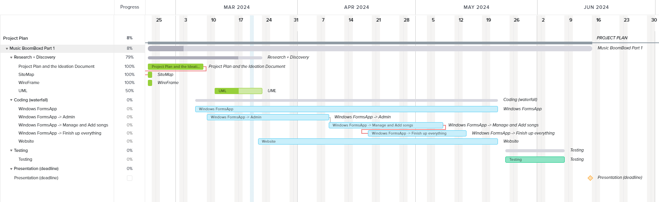
Time plan and milestones

Testing strategy and configuration management

Testing strategy

- Unit Testing:
Unit testing is essential for ensuring the correctness and reliability of individual code units. It helps detect and fix defects early in the development process, promoting code quality and maintainability.

- Acceptance Testing:
Acceptance testing ensures that the system meets the expectations and needs of the end-users, verifying that it fulfills its intended purpose and delivers value to stakeholders.

Configuration management

GitLab is used as the primary version control system and project management platform. GitLab offers integrated features for source code management, issue tracking, continuous integration, and deployment pipelines, streamlining collaboration and project workflows.

Only fully tested and approved changes are merged into the main branch. Developers merge their feature branches into the development branch for integration testing and validation.

GitLab enables the creation of release tags and milestones to mark significant project releases. Releases are managed through GitLab's release management features, allowing teams to track release progress, associated issues, and release notes.

GitLab provides tagging functionality to create baselines for stable and approved versions of the codebase. Tags are used to label specific commits or merge requests, indicating milestone releases, hotfixes, or other significant changes.

Issues are logged, categorized, and assigned to team members for resolution.

Using GitLab's issue boards, milestones, and epics, a standardized workflow will be established to track the progress of change requests and problem reports from submission to resolution.

Finances and risk

Risk and mitigation

Risk | Prevention activities | Mitigation activities
1 Sickness | Even distribution of work | Plan everything
2 Client Expectations  Different from Result | Weekly meetings with client | Deliverables clearly stated in Project Plan
- Loss of Data | Git for Version Control | + Recover as much as possible
- Server Problems | Local Backups | Go to ISSD/Complain
7 Low Productivity | Setting small goals | Look back at the initial picture of the project

